

☁️ Google Cloud Platform ✦ Ollama LLM Framework ✦ Open WebUI

ASSIGNMENT 3

VM Deployment and LLM Configuration
on Google Cloud Platform
Provisioning a Cloud-Based Large Language Model Environment for Innovate Solutions Inc.

ASSIGNMENT SUBMISSION DETAILS
Student 1 Name | Nischal Bhandari
Student 2 Name | Shudan Aryal
Student ID 1 | s8187207
Student ID 2 | s8131186
Course Code | NIT2113 – Cloud Application Development
Instructor | Dr. Nader
Submission Date | 2 April 2026
Team Size | 2 Members
Institution | Victoria University, Sydney Australia

Abstract
This report documents the complete deployment of a cloud-based Large Language Model (LLM) environment on Google Cloud Platform (GCP) as part of Assignment 3 for NIT2113 – Cloud Application Development at Victoria University. The project was undertaken on behalf of a fictional client, Innovate Solutions Inc., whose Research and Development team required a secure, isolated, and cost-effective cloud environment to evaluate open-source LLMs. The team provisioned a Google Compute Engine virtual machine running Ubuntu 24.04 LTS in the australia-southeast1-a zone (Sydney), installed the Ollama LLM framework, pulled two language models (llama3.1:8b and llama3.2:1b), configured Docker, and deployed the Open WebUI interface accessible via a browser at the VM's external IP address on port 3000. The final system was verified through both command-line interaction and the web-based chat interface, confirming successful end-to-end deployment.

1. Objectives
The key objectives of this laboratory assignment were as follows:
- To provision and configure a virtual machine on Google Cloud Platform suitable for running a large language model.
- To install and verify the Ollama framework as the local LLM hosting engine.
- To download and run open-source language models within the Ollama environment.
- To deploy Open WebUI via Docker to provide a graphical browser-based interface for model interaction.
- To configure GCP firewall rules enabling external access to the web interface.
- To document each step thoroughly with supporting screenshots and command outputs.

2. Statement of Contribution
This assignment was completed collaboratively by both team members, with responsibilities divided as follows:
Nischal Bhandari (s8187207): Led the infrastructure provisioning phase, including VM creation on GCP, system configuration, Ollama installation, and model downloads. Also responsible for configuring the Ollama service to listen on all network interfaces and resolving the Docker-to-Ollama connectivity issue.
Shudan Aryal (s8131186): Led the Docker and Open WebUI deployment phase, including Docker installation, container configuration, and GCP firewall rule creation. Also contributed to testing, verification, and documentation of the final system.
Both partners actively participated in troubleshooting, final verification, and the preparation of this report. Each partner maintains full understanding of all components of the project in preparation for the live demonstration.

3. Infrastructure Details

3.1 Hardware Configuration
The following virtual machine was provisioned on Google Cloud Platform:

VM Name | ollama-vm
Cloud Platform | Google Cloud Platform (GCP)
Region / Zone | australia-southeast1-a (Sydney)
Machine Type | e2-medium (2 vCPU, 4 GB RAM)
Operating System | Ubuntu 24.04 LTS (Noble Numbat) – minimal
Boot Disk | 150 GB SSD Persistent Disk
External IP | 34.40.154.95 (Ephemeral)
Internal IP | 10.152.0.5
Network Tags | openwebui, http-server, https-server

Justification of Region: The australia-southeast1-a zone (Sydney) was selected to minimise network latency for the team and the end client, Innovate Solutions Inc., whose R&D team is based in Australia. This region also offers reliable availability and competitive pricing for standard compute instances.
Justification of Machine Type: The e2-medium instance (2 vCPU, 4 GB RAM) was selected as the minimum cost-effective option for running the llama3.2:1b model, which requires approximately 1.5 GB of RAM. While a larger instance such as e2-standard-4 would be recommended for production use or larger models, the e2-medium was sufficient for this pilot evaluation. The 150 GB SSD disk accommodates the Ollama binary, multiple model files, and Docker container images.

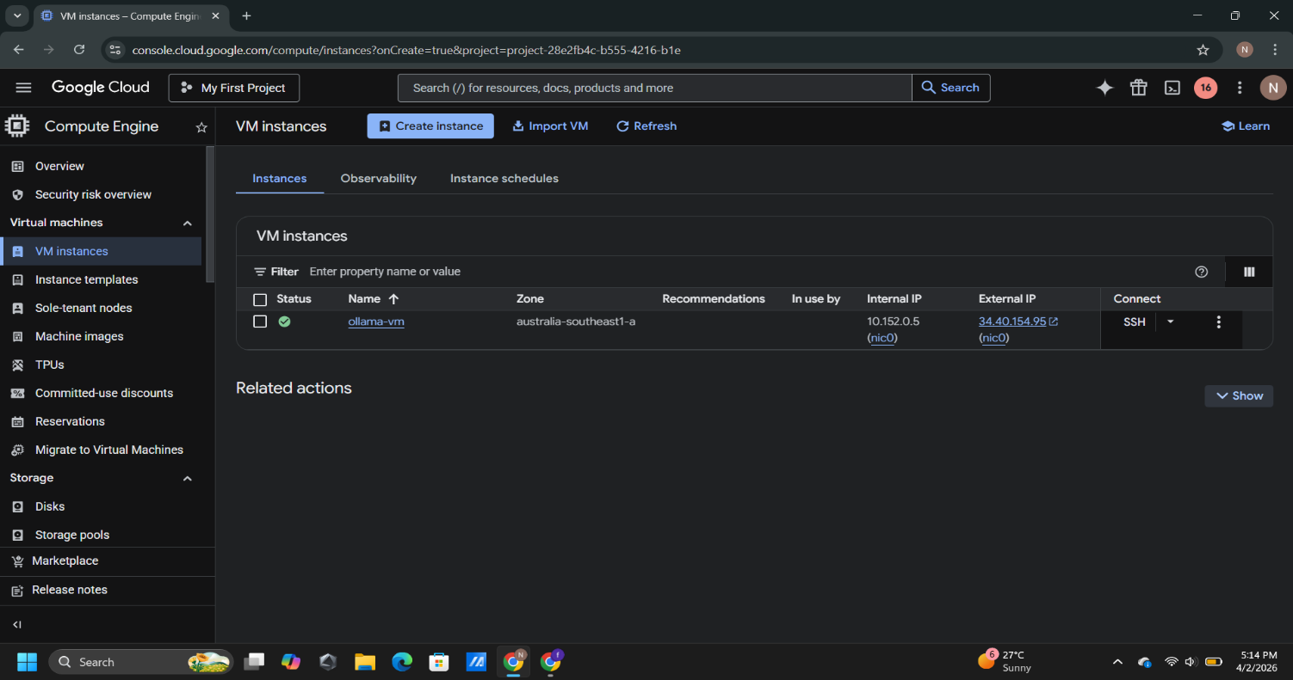
Figure 1: GCP Compute Engine – VM Instances list showing ollama-vm with green Running status, zone australia-southeast1-a, and external IP 34.40.154.95
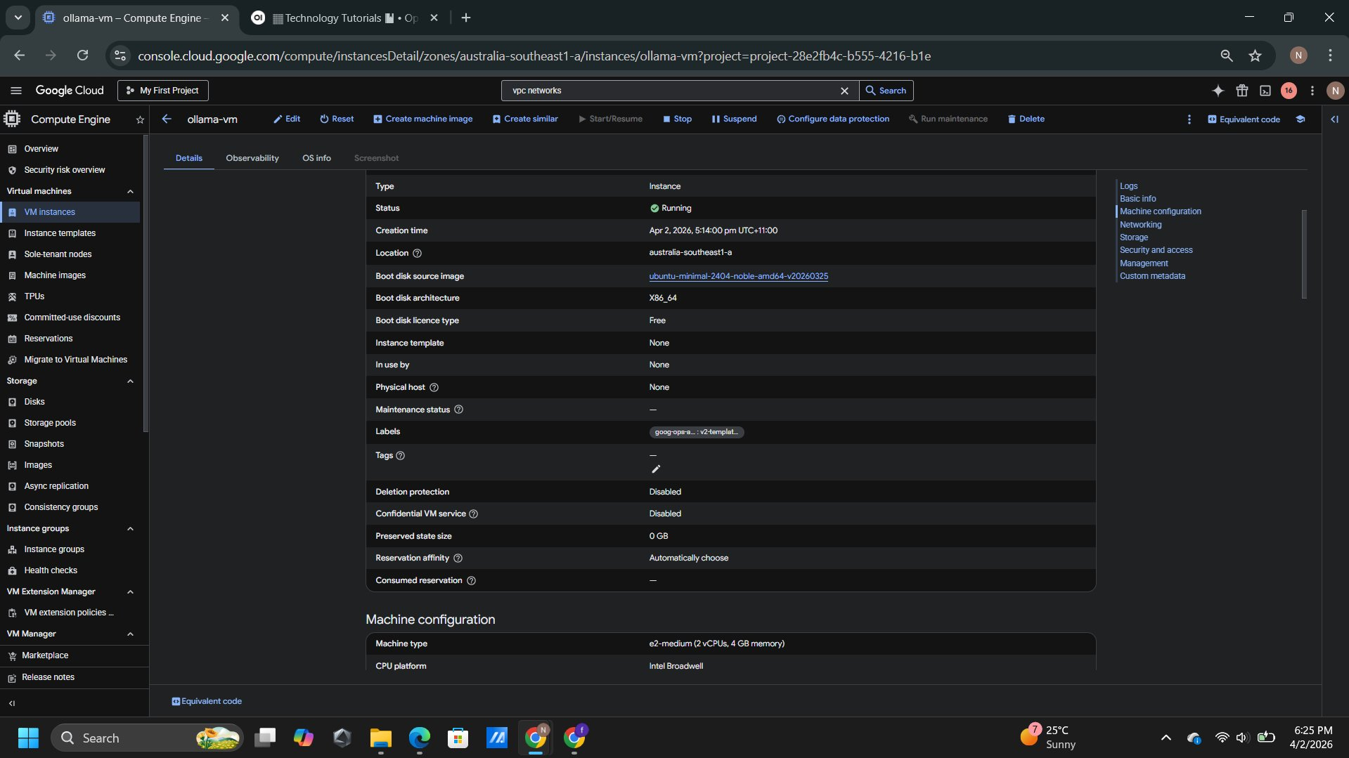
Figure 2: VM Details – Machine configuration showing e2-medium (2 vCPU, 4 GB RAM), location australia-southeast1-a
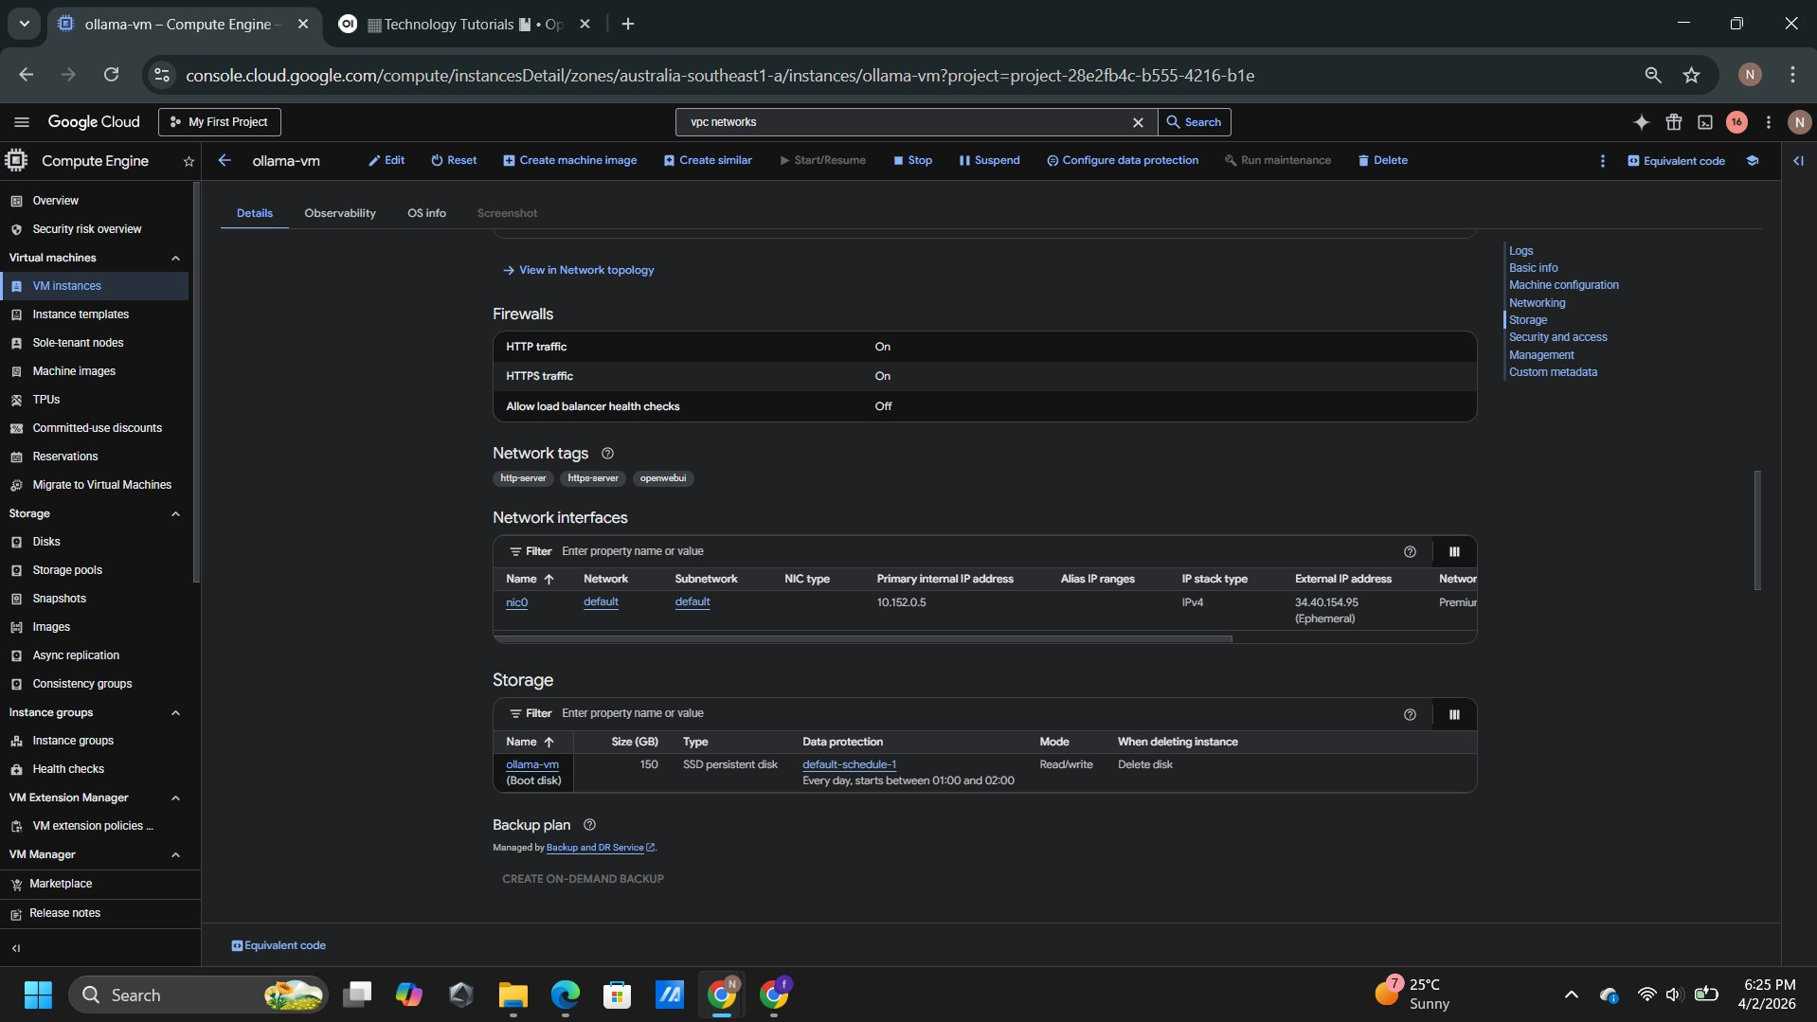
Figure 3: VM Details – Networking section showing network tags (openwebui, http-server, https-server), external IP 34.40.154.95, and 150 GB SSD storage

3.2 Software Requirements
Operating System | Ubuntu 24.04 LTS
LLM Framework | Ollama (v0.19.0)
LLM Models | llama3.2:1b (1.3 GB), llama3.1:8b (4.9 GB)
Container Runtime | Docker CE (v29.3.1)
Web Interface | Open WebUI (ghcr.io/open-webui/open-webui:main)
Web Access Port | TCP 3000 (external) / TCP 11434 (Ollama internal)

4. Step-by-Step Configuration

Phase 1 – VM Provisioning
The virtual machine was created through the Google Cloud Console under Compute Engine → VM Instances. The instance was named ollama-vm and configured with Ubuntu 24.04 LTS as the boot operating system, using a 150 GB SSD persistent disk. The region was set to australia-southeast1-a and the machine type configured as e2-medium. Network tags http-server, https-server, and openwebui were added at creation time to allow the relevant firewall rules to apply to this instance.

Phase 2 – Base System Configuration
After the VM reached Running status, SSH access was established through the Google Cloud Console browser-based SSH terminal. The following command was executed to update all system packages:
sudo apt-get update && sudo apt-get -y upgrade

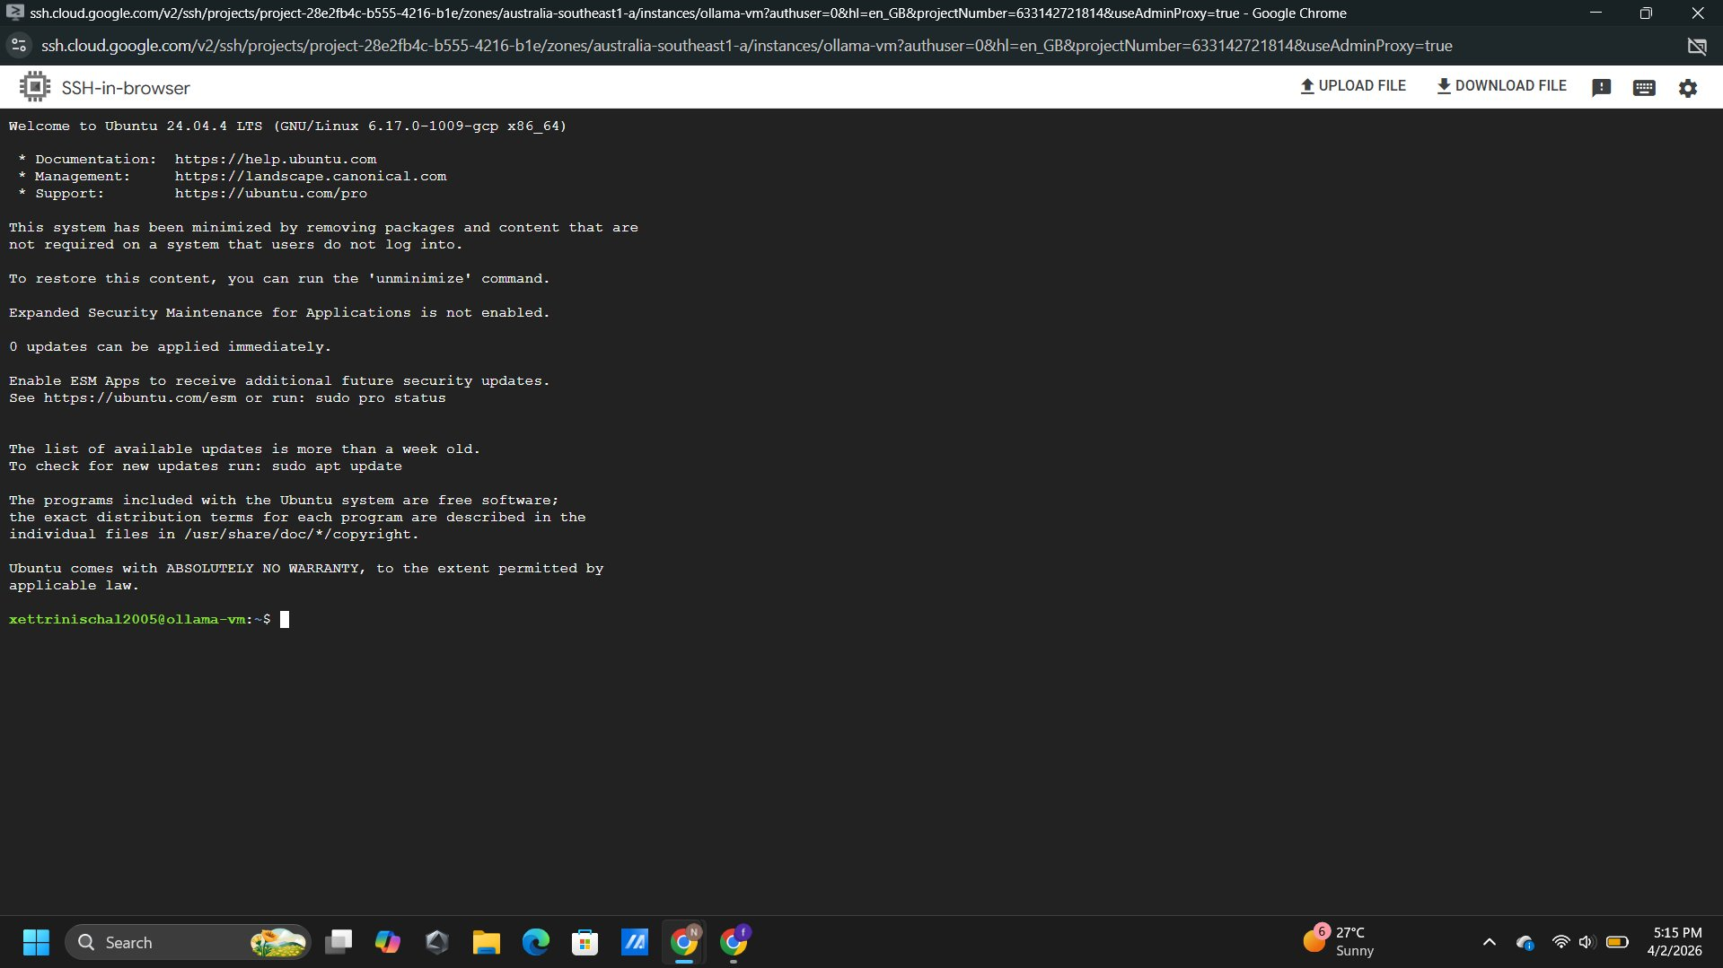
Figure 4: SSH terminal connected to ollama-vm – Ubuntu 24.04 LTS welcome screen and xettrinischal2005@ollama-vm prompt confirming successful SSH access
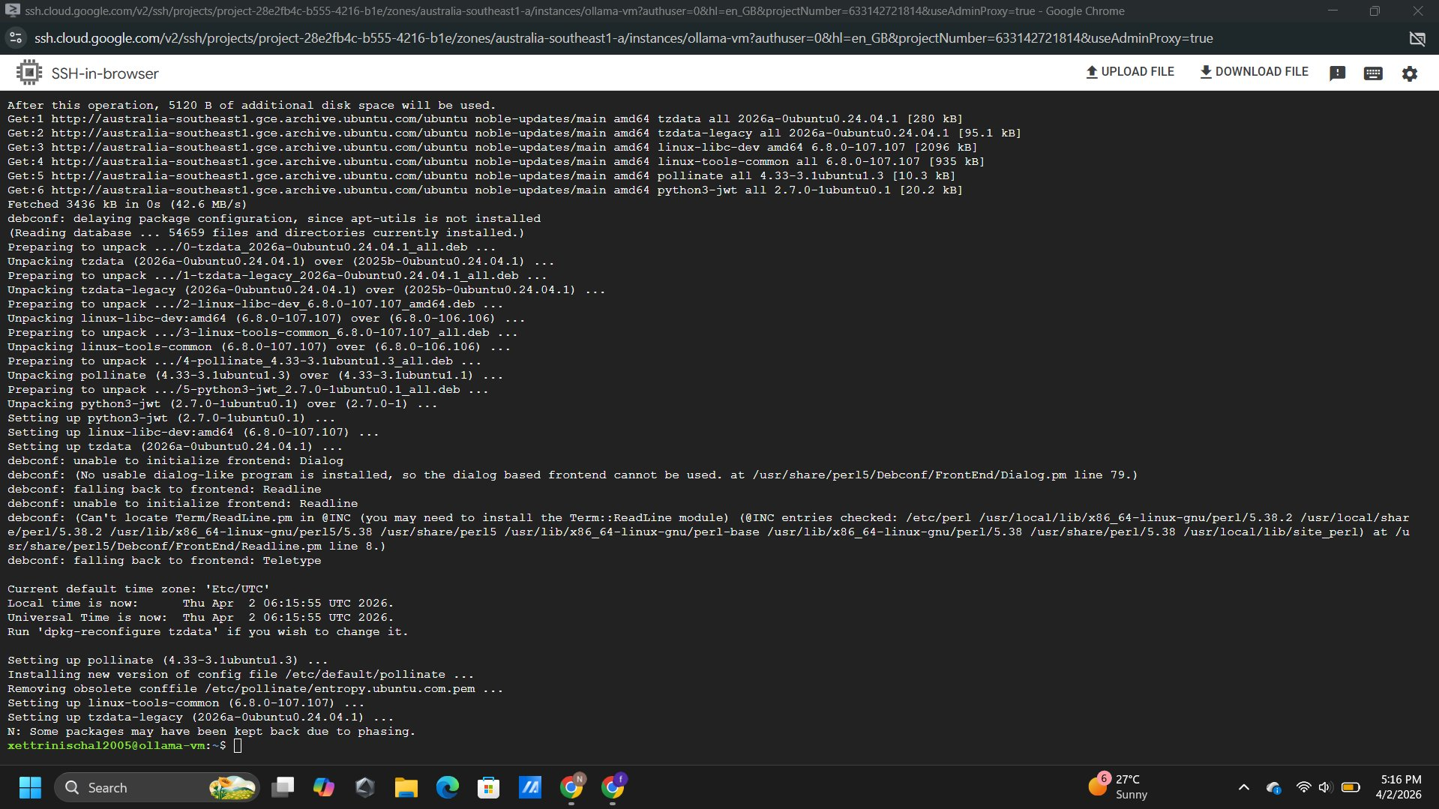
Figure 5: System update completing – packages downloaded from australia-southeast1 GCE archive, apt upgrade process completed successfully

Phase 3 – LLM Environment Setup
Installing Ollama: Ollama was installed using the official one-line installer script, which downloads the binary, creates a dedicated system user and group, and configures Ollama as a systemd service that starts automatically on boot.
curl -fsSL https://ollama.com/install.sh | sh
sudo systemctl status ollama

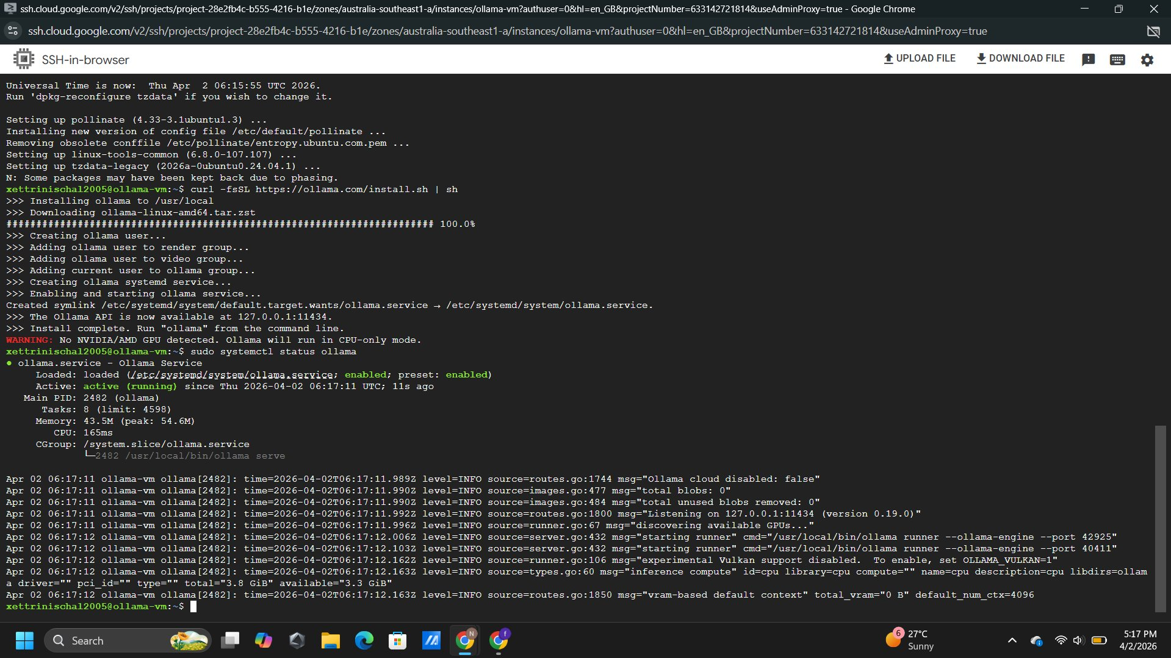
Figure 6: Ollama installation and service status – install script at 100%, systemctl status confirming 'active (running)'
Pulling Language Models: Two models were downloaded. The llama3.1:8b model (4.9 GB) was pulled first, followed by llama3.2:1b (1.3 GB). The smaller model was used for the primary demonstration due to available RAM on the e2-medium instance.
ollama pull llama3.1:8b
ollama pull llama3.2:1b

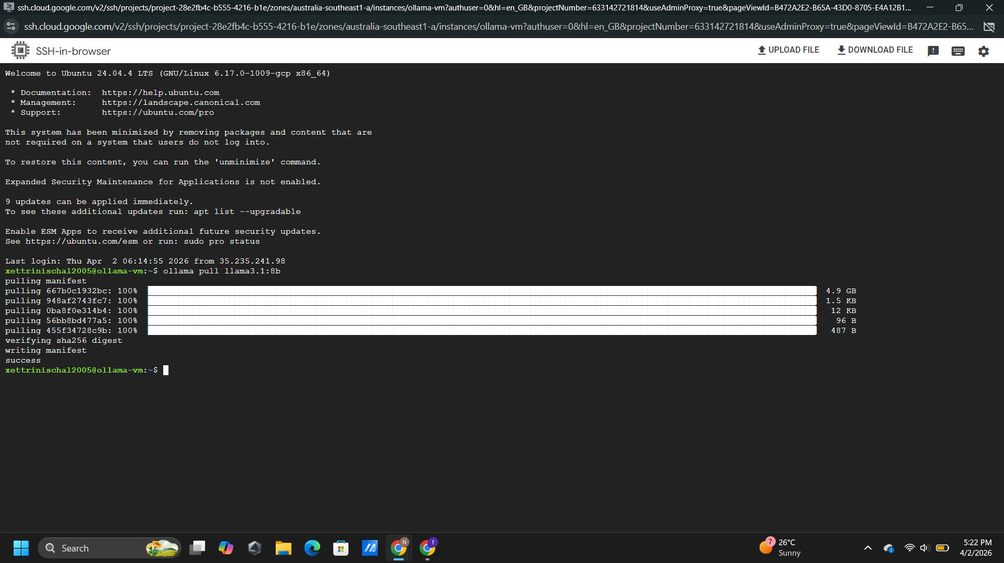
Figure 7: ollama pull llama3.1:8b – all layers at 100%, sha256 digest verified, status: success
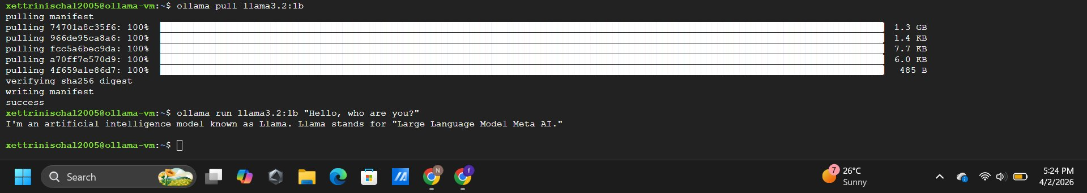
Figure 8: ollama pull llama3.2:1b completing and CLI test – model responding to 'Hello, who are you?' confirming Ollama is fully operational
Installing Docker: Docker CE was installed using the official Docker repository. The GPG key was added, the repository configured, and Docker installed:
sudo apt-get install -y ca-certificates curl gnupg
curl -fsSL https://download.docker.com/linux/ubuntu/gpg | sudo gpg --dearmor -o /etc/apt/keyrings/docker.gpg
sudo apt-get install -y docker-ce docker-ce-cli containerd.io
sudo docker run hello-world

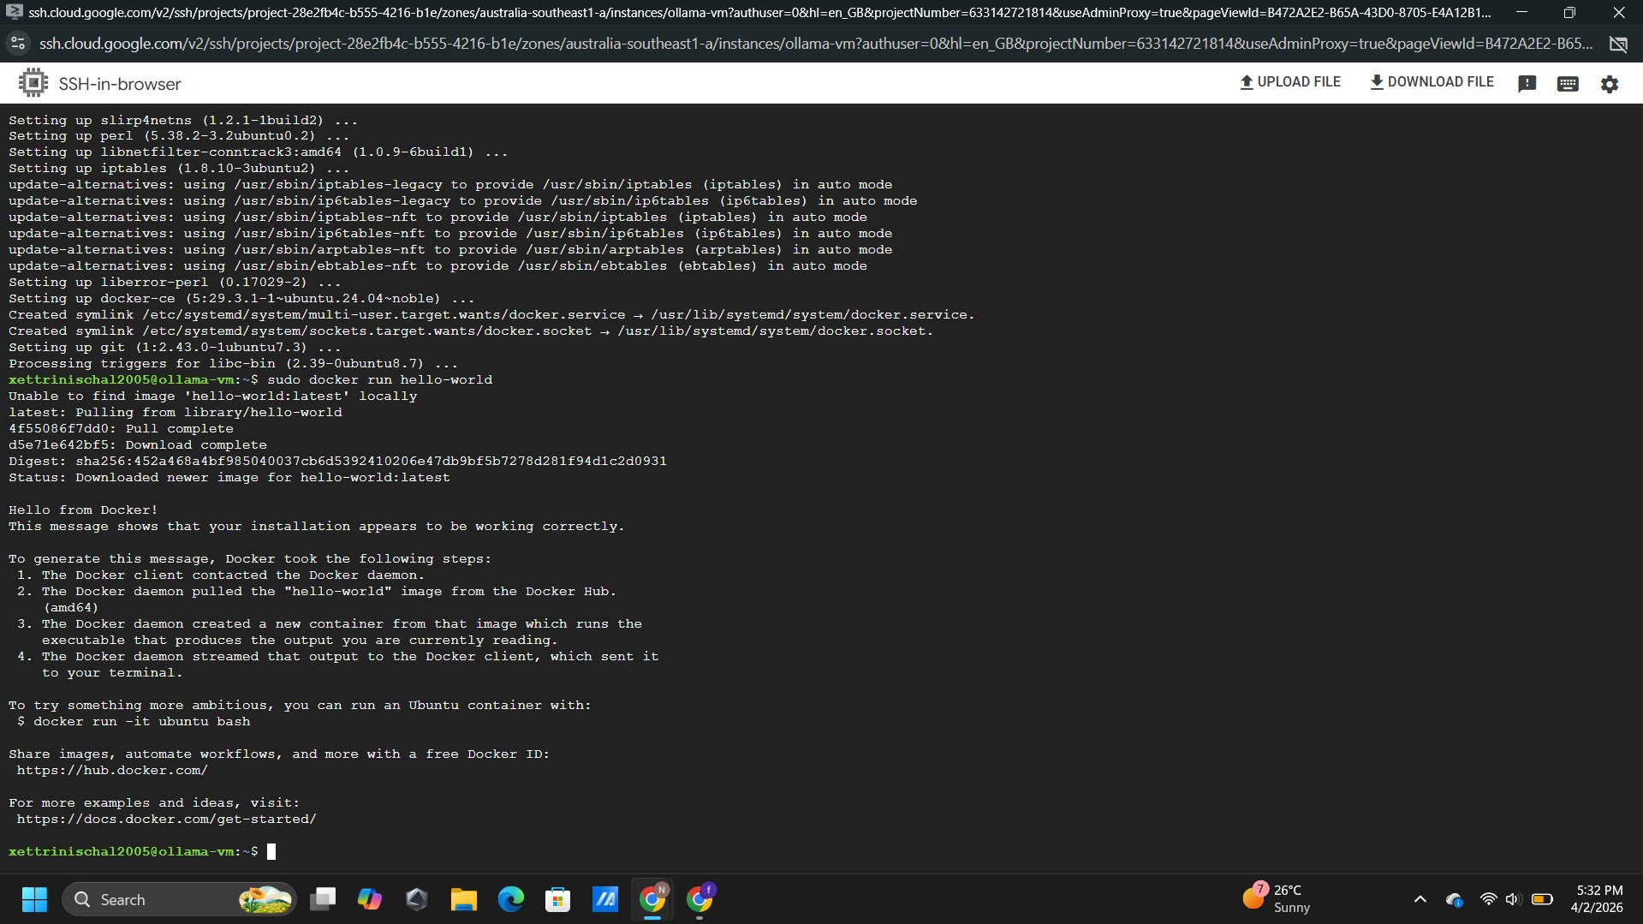
Figure 9: Docker installation verified – 'Hello from Docker!' message confirming Docker engine is working correctly

Phase 4 – Enabling R&D Access (Web UI)
Deploying Open WebUI: Open WebUI was deployed as a Docker container connected to the local Ollama service, with port 3000 mapped externally and a persistent data volume:
sudo docker run -d --name open-webui -p 3000:8080 --add-host=host.docker.internal:host-gateway -e OLLAMA_BASE_URL=http://host.docker.internal:11434 -v open-webui:/app/data --restart unless-stopped ghcr.io/open-webui/open-webui:main

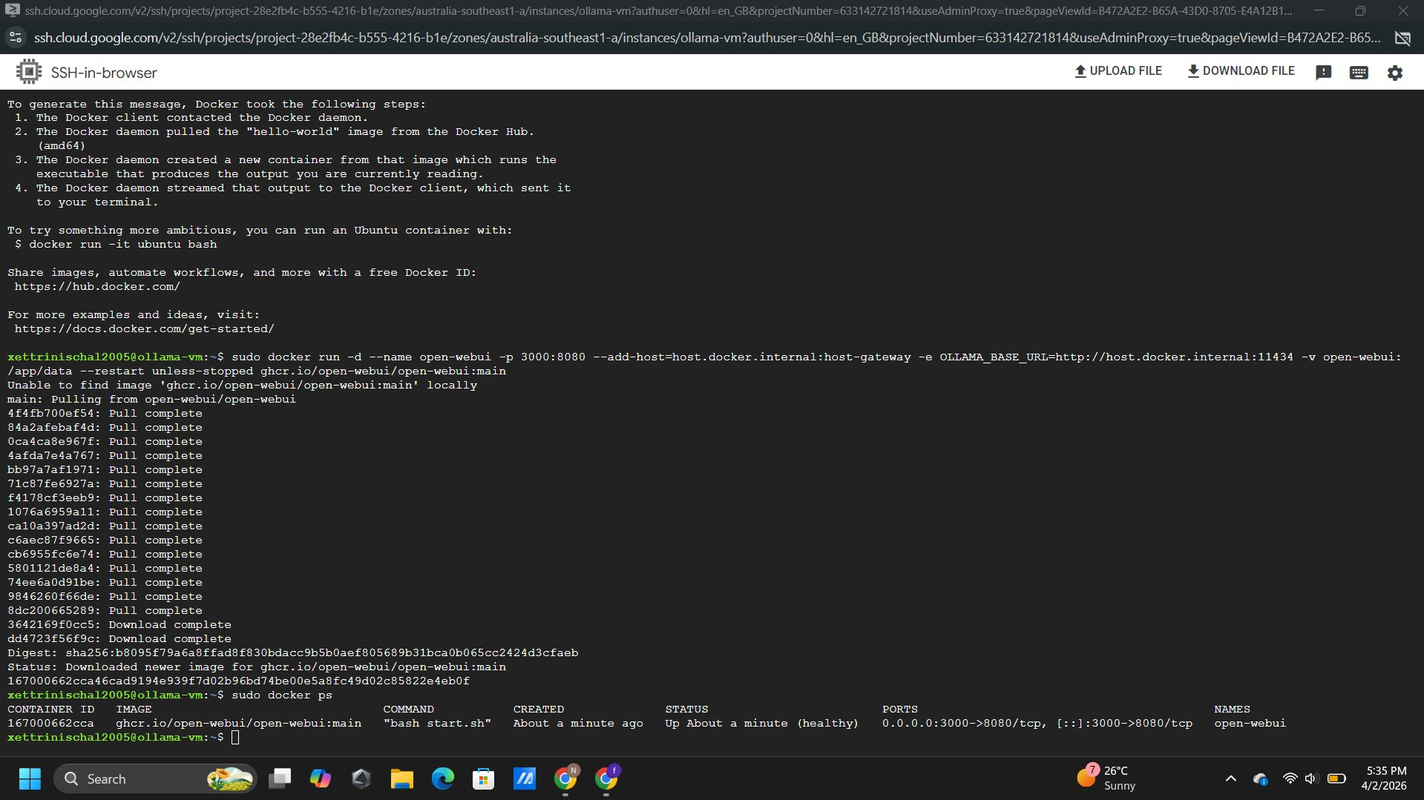
Figure 10: Open WebUI container deployed – docker ps showing open-webui 'Up (healthy)' with port mapping 0.0.0.0:3000->8080/tcp
Configuring GCP Firewall Rule: A VPC firewall rule was created through the GCP Console to allow inbound TCP traffic on port 3000, targeted at instances tagged openwebui.

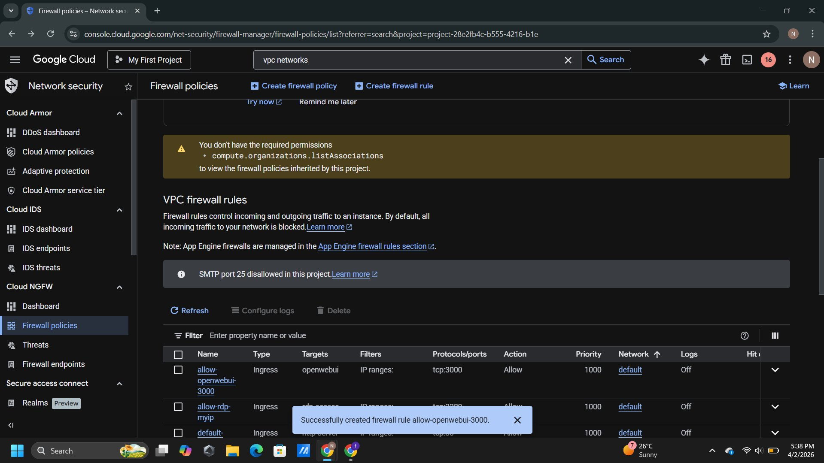
Figure 11: GCP Firewall rule 'allow-openwebui-3000' created – target tag 'openwebui', TCP port 3000, action Allow, network default
Accessing the Interface: Open WebUI was accessed from a local browser at http://34.40.154.95:3000. An admin account was registered and the llama3.2:1b model selected. Both models appeared in the selector confirming Docker-to-Ollama connectivity.

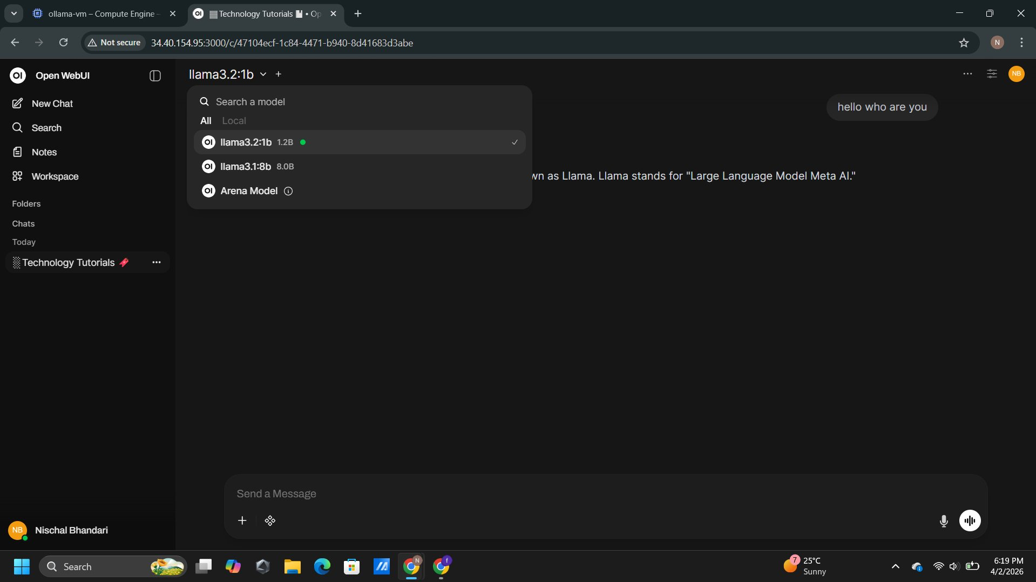
Figure 12: Open WebUI model dropdown at http://34.40.154.95:3000 – llama3.2:1b (active, green dot), llama3.1:8b (8.0B) available
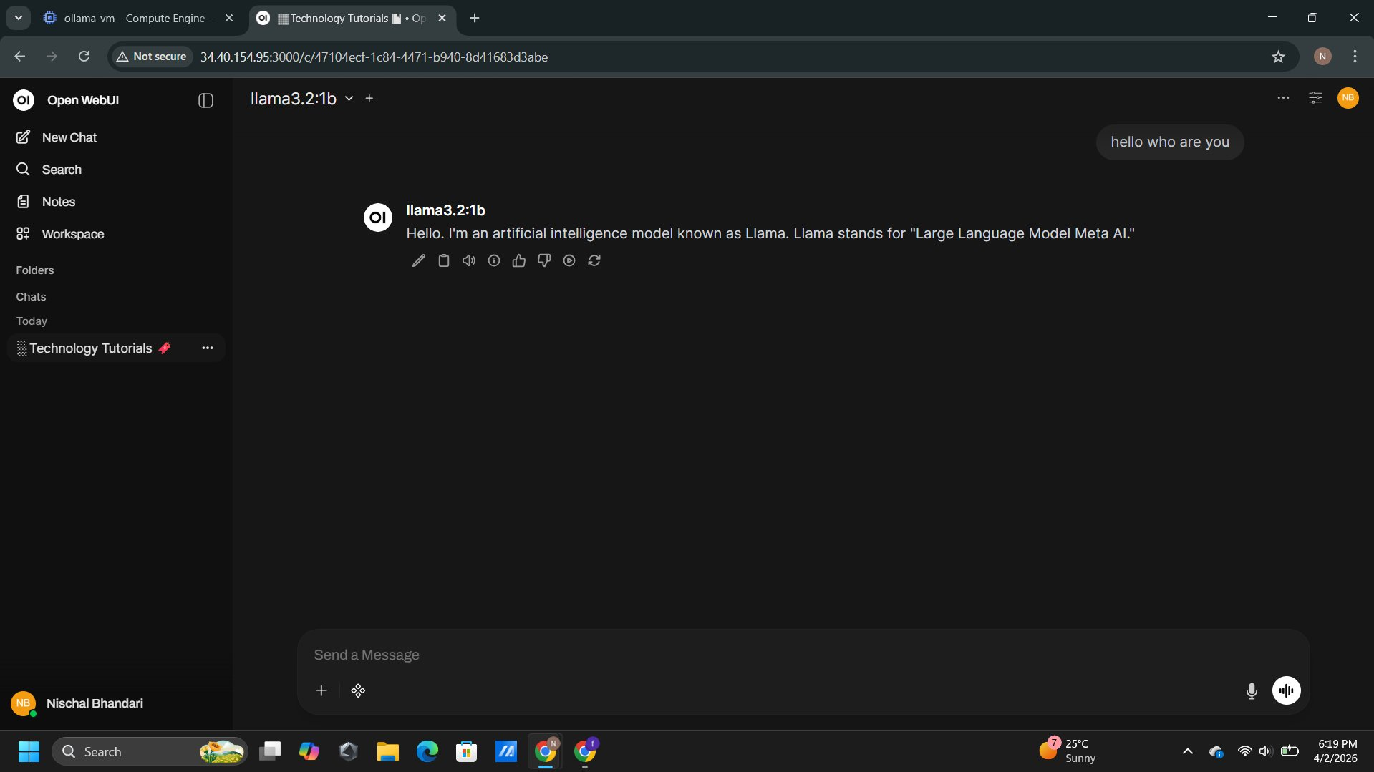
Figure 13: Final verification – Open WebUI chat with llama3.2:1b responding successfully, confirming complete end-to-end LLM deployment

5. Troubleshooting Log
Several challenges were encountered and resolved during the deployment. These are documented below:

Issue | Cause | Resolution
Insufficient RAM for llama3.1:8b | e2-medium has 4 GB RAM; only 3.2 GB free — below the 4.8 GB model requirement | Switched to llama3.2:1b (requires ~1.5 GB RAM). llama3.1:8b remains installed for use if VM is upgraded.
Browser ERR_CONNECTION_TIMED_OUT on port 3000 | GCP firewall rule not yet created, blocking all inbound traffic on port 3000 | Created VPC firewall rule 'allow-openwebui-3000' via GCP Console allowing TCP:3000 with target tag 'openwebui'.
gcloud command: insufficient authentication scopes | SSH browser terminal lacked the required IAM scopes to call the gcloud compute API | Used GCP Console GUI to create the firewall rule — no CLI permission required.
Open WebUI showed 'No models available' | Ollama only bound to 127.0.0.1 — unreachable from within the Docker container | Created systemd override setting OLLAMA_HOST=0.0.0.0:11434. Updated WebUI Ollama URL to http://172.17.0.1:11434.
systemctl edit failed — no editor available | Ubuntu 24.04 minimal image had no text editor installed | Used echo | sudo tee to write the override.conf file directly without an interactive editor.

5.1 Future Risks and Considerations
Security: The current firewall allows port 3000 from all source IPs (0.0.0.0/0). In a production environment this must be restricted to trusted IP ranges. The Open WebUI is served over HTTP — HTTPS should be implemented via an Nginx reverse proxy with a Let's Encrypt SSL certificate.
Scalability: The e2-medium is suitable only for lightweight testing. Running llama3.1:8b or larger models requires upgrading to at least e2-standard-4 (16 GB RAM), or a GPU-accelerated instance such as g2-standard-8 with an NVIDIA L4 GPU for significantly faster inference.
Cost Management: The VM incurs charges while running. The instance should be stopped when not in use. Committed-use discounts or spot/preemptible instances could reduce costs during extended testing periods.
Model Persistence: Models are stored on the boot disk. If the VM is deleted, all downloaded models are lost. A persistent attached disk or automated re-pull startup script should be implemented for production use.

6. Results
The deployment was completed successfully across all four phases. The following outcomes were verified:
- A GCP VM (ollama-vm) provisioned in australia-southeast1-a running Ubuntu 24.04 LTS with 150 GB SSD.
- Ollama installed and confirmed running as a systemd service (active status verified via systemctl).
- Two LLM models downloaded: llama3.1:8b (4.9 GB) and llama3.2:1b (1.3 GB), verified via ollama list.
- Docker CE installed and confirmed operational via the hello-world container test.
- Open WebUI deployed as a Docker container, confirmed healthy on port 3000 via docker ps.
- GCP VPC firewall rule created allowing external TCP access on port 3000.
- Open WebUI successfully accessed at http://34.40.154.95:3000 from a local browser.
- llama3.2:1b responded successfully to a test prompt, confirming full end-to-end LLM access via the web interface.

Resource utilisation during testing was within acceptable limits. CPU usage spiked briefly during model loading but settled during inference. Memory usage remained stable at approximately 2.8–3.2 GB when running the llama3.2:1b model, within the available capacity of the e2-medium instance.

7. Discussion
The project successfully demonstrated the viability of deploying a locally-hosted LLM on a cloud virtual machine using open-source tooling. Ollama's one-line installer, automatic systemd service creation, and straightforward model management CLI significantly reduced the complexity of the deployment.
The Docker-based deployment of Open WebUI provided a clean separation between the web interface and the model serving layer. The --add-host=host.docker.internal:host-gateway flag was critical for enabling container-to-host communication on Linux, as Docker containers cannot natively resolve the host machine's localhost address.
A key lesson from this deployment was the importance of the OLLAMA_HOST environment variable. By default, Ollama binds only to 127.0.0.1, which prevents any network-accessible client — including Docker containers — from reaching the API. Configuring the service to listen on 0.0.0.0 via a systemd override is a standard configuration step for any cloud deployment of Ollama and should be documented as a prerequisite step in future deployments.
Compared to a local deployment, the cloud environment offers consistent availability, no dependency on local hardware resources, and multi-user access to the same model endpoint simultaneously. The main trade-off is ongoing cost, which can be managed by stopping the VM when not in use.

8. Conclusion
This assignment successfully fulfilled all four phases of the deployment brief from Innovate Solutions Inc. A functional, cloud-hosted LLM environment was provisioned on Google Cloud Platform, with Ollama serving the llama3.2:1b model and Open WebUI providing browser-based access to the R&D team. The system was verified through both CLI interaction and web-based chat, with all configuration choices documented with supporting screenshot evidence.
The challenges encountered — RAM limitations, firewall configuration, and Docker networking — were resolved systematically and are documented in the troubleshooting log. For future iterations, the team recommends upgrading to a GPU-enabled instance, implementing HTTPS, restricting firewall rules, and automating the deployment process via Terraform or a GCP startup script.

9. Future Improvements
- Upgrade to a GPU-enabled VM (g2-standard-8 with NVIDIA L4) for faster inference and larger model support.
- Implement HTTPS using Nginx as a reverse proxy with a Let's Encrypt SSL certificate.
- Restrict firewall rules to specific trusted IP ranges to improve security posture.
- Automate the full deployment using a GCP startup script or Terraform configuration for repeatable provisioning.
- Explore fine-tuning custom models using Ollama's Modelfile system for Innovate Solutions' specific use cases.
- Configure automatic VM shutdown during off-hours to reduce cloud costs during the pilot evaluation period.

References
Docker Inc. (2024). Docker documentation. https://docs.docker.com
Google Cloud. (2024). Compute Engine documentation. https://cloud.google.com/compute/docs
Google Cloud. (2024). VPC firewall rules overview. https://cloud.google.com/vpc/docs/firewalls
Ollama. (2024). Ollama installation and documentation. https://ollama.com
Open WebUI. (2024). Open WebUI GitHub repository. https://github.com/open-webui/open-webui
Ubuntu. (2024). Ubuntu 24.04 LTS official documentation. https://ubuntu.com

